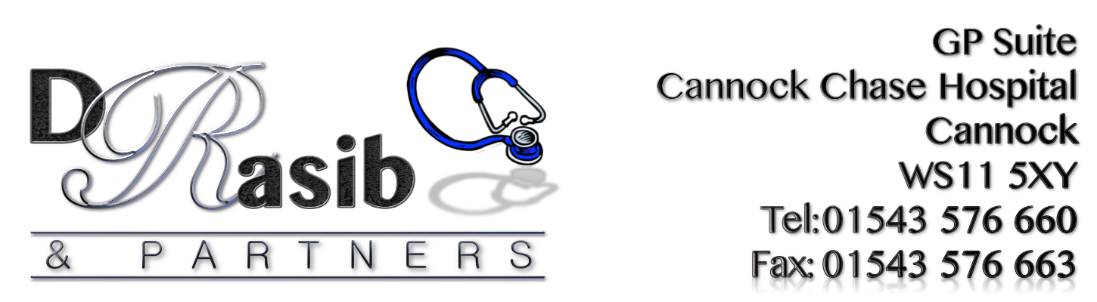
RESULTS FOR PATIENT SURVEY 2019

77% stated that they were aware of medications that now have to be purchased over the counter – No action required

91% stated that they considered that the practice was providing good, reliable service of care/treatment – No action required

20% of patients stated that getting through on the phone was poor. However the practice is aware that getting through on the phones has been an on-going problem and is still working with the hospital to try and introduce a new phone system - This item is to be included on the Action Plan.

13% of patients stated that trying to get an appointment easily was poor. This is an improvement on last year’s results when 15% of patients stated that getting an appointment easily was poor. - This item is to be included on the Action Plan.

86% of patients surveyed were happy with the service provided by the receptionists, this shows to be slightly lower than last year and the team will be asked to continue to provide a high level of customer service at all times – No action required.

91% of patients surveyed were happy with the service provided by the Clinical Staff. Although these results are positive, the practice will ensure that the team continue to provide a high level of customer service at all times – No action required.

74%% of patients stated that they were aware of Patient Access. However the practice would like to continue to actively promote this service as it allows accuracy & efficiency to be maintained by both parties and provides lots of advantages for the patient - This item is to be included on the Action Plan.

GENERAL COMMENTS RECEIVED:

COMMENTS:
- Never had any problems/care supplied by Dr Rasib & staff. Sometimes have problem with Patient Access
- Just hard to get through on the phone for an appointment otherwise excellent. Thank you.
- It is very hard to get appointments and often can’t get through in the morning until 8.30am, when appointments have already gone
- I find it very difficult to book an appointment on the day as the phone line is too busy to get an answer and by the time I drive up it’s too late!
- Patient Access doesn’t work. Some receptionists are really helpful.
- Take 20 minutes to get through to make appointment, then told none left try next day.
- I always try to see Dr Sarwar who is an excellent doctor. I don’t have too much problem getting an appointment but it can be difficult if you specify a doctor.
- Thank you. The Truby Family are very pleased with the care & service they receive
- Appointment system needs updating, not easy to get an appointment when working
- Feel more late night appointments should be available for people that work full time and cannot make daytime. Receptionists need to have a smile and be a little more
- Helpful when they see a patient in need or struggling anxiety wise
- Minor treatments available in surgery to prevent patients having to travel to New Cross + some are challenged financially and physically
- Ongoing problem due to visit to GP, I find the problem is not the surgery but the NHS overall – waiting times are ridiculous (out of the GPs hands

SUGGESTION COMMENTS:
- I don’t think receptionists should be asking what you want to see the Doctor for, not appropriate
- Get a car park so it’s closer to Doctors and no charge

